AGs Project description on eBib-Scripts
Table of Content
Situation 3
Purpose of the Scripts 3
Size of my meta collection 3
Filetypes 3
My ideas for a solution of the problem 4
What is the comparison criteria? 4
Additional Service: reduce redundancy by duplication 5
Step 1 duplication 5
Step 2 double folder 5
The compare-part 5
Or even better: exchange via our server 6
Later sub project in the future 6
The first milestone 6
Software-Service should be paid by community 7
How to use the scripts 7
Overview 7
Installation of perl necessary 7
Compiling 7
Installieren des Compilers 8
Befehl zum compilieren 8
list-all-files 8
User Agreement 8
Commands to apply the app 8
Duration of Script 9
Search-for-Dates 10
Description of development for the programmer 10
The Purpose 10
Already solved 10
Examples for Dates 10
Any white-spaces 11
A 2-digit year 11
Unknown Day 11
1st, 2nd, 3rd 12
Revision-Markers 12
Multiple Dates 12
Debug Info 12
Applications 13
1. process list-all-files-v022.pl 13
2.a A revision of list-all-files-v022.pl 14
2.b Use of the same script on a website as a service for visitors 14
3. Use on Text-files 14
2nd try to explain this: 14
Notes on Testing 15
Öffnen der .tsv durch Calc 15
Beobachtungen 15
Irritation durch Anführungsstriche im Dateinamen? 29804 rec. 15
Reading files in JavaScript using the File APIs 16
Test Runs 16
nohup 16
Dauer 16
Commands to apply the app 16
compare-n-share 16
Usage 17
A small bug: 17
How to Run the Copy-script 17
Dedup-Files 17
Das eb script, ebb, ebm und erstens 18
erstens 18
eb 18
ebb 18
ebm 18

Situation

Purpose of the Scripts
I am a collector of certain files and the items include eBooks, pdf, doc, txt, images, audio, video etc; in short: all kind of documents in files. And I have already a 7 TB HDD with a few million files on it.
- Now and then I will meet a similar collector (same special interests)
- and we want to exchange: what do I not have, what he has and vice versa.
- and it is impossible to compare that manually as they are millions files and he organizes them in a different folder-tree than me. So any existing software to compare folders will fail.
- and all the 7 TB in 100`000+ folders
to make it even more complicate: collectors rename the files and reorganize the folders to use the file system for adding document attributes. This makes it even harder to find redundant files.

Size of my meta collection

Filetypes
And here you see the types of documents and the number for each type:
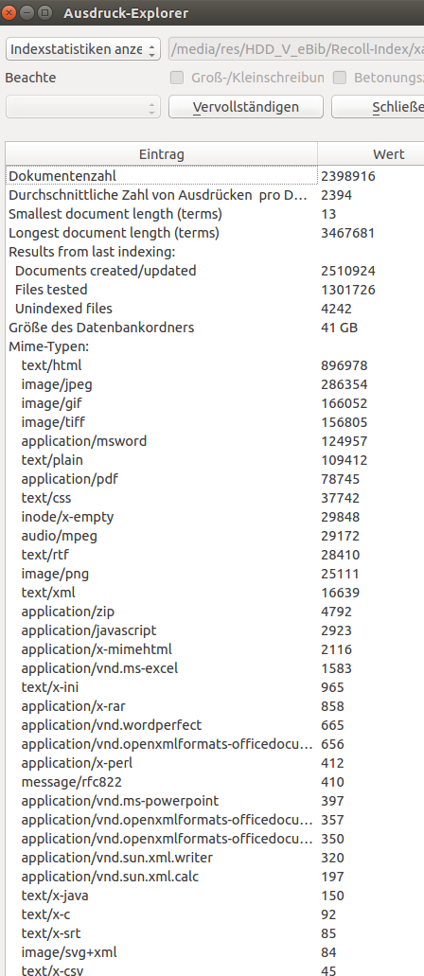

My ideas for a solution of the problem

What is the comparison criteria?
We are looking for files of identical content. Do not care about different filenames.
my idea: calculate a hash i.e. SHA-512 for each file in his folder(s) (and in my folder) and put each file into a line : path, filename, size, date, hash
This would be the first script.
It needs to be cross-platform:
- Win (Win10 and also back to WinXP)
- Linux
- Mac
A Perl script to calculate the hashing.
Lets call this script «list-all-files»: LAF
The hash-coded-list, human readable (.csv), which the enduser can review (that he does not give out info, he does not like to give) and edit (delete the lines he does not want to reveal) and then import that to our website – registered and logged in - under his username.

Additional Service: reduce redundancy by duplication
This is just an additional feature to the basic «compare-n-share», but I put this first, as it is an easier task in programming and in using it. You do not need any agreement between 2 collectors, as it is just a service for a single collector himself.
The problem, which could be solved for the collectors would be this:
They probably have lots of redundant files and even folders with sub-folder and files, they already own. This because they already cooperated without such sophisticated software we are going to create. I estimate this often to be more than 50% of their HDD resources to gain.

Step 1 duplication
For this we just sort the given .csv-table by Hash and count by hash and list all double, triple, quadruple … entries.
Output the results (only redundant files) as a text file. And as a cmd-file. These should be crossplatform (or for all 3 platforms)
As a text file so that it can be edited manually by the owner, in case he does not want to give out one or the other folder or file.
So these double files (redundancy) could be replaced by hard links or similar to save HDD space.
Do not just delete them, because the path and filename (which might be different than the original file) might contain valuable attributes about the document: author, date, publisher, language, version, title, … - all metadata.

Step 2 double folder
Even better than to find redundancy on a file level would be to find identical folders (including content: files plus same filenames):
So the script would calculate a summarised value for each folder (including subfolder and files in it) and when it finds 2 folders with identical sums (file count, file size and sum of hash and sum over all filenames) then we have identical folders and can replace one of them with a hard link to the other. If all these are identical, it would be save to replace the whole tree with a hard link.

The compare-part
This is the killer app: why people will love to join in.
Although on a daily basis new books or audio tapes are scanned in and collected, the collectors are tired of exchanging their hard work, as they are in confusion, how to find the files in the other guys collection, they do not have yet.
And this 3rd script runs on a webserver, accessible to all registered users. Perhaps we should use a CMS as a platform. i.e. I have a Wordpress-blog, where the compare-part can be added as a plugin and runs on a page, which is only accessible to registered users. So the script adds the username to the DB-table and also imports the .csv-file to the table.
In this wise we have in our DB a collection of all the collections (.csv-Files) which where entered by members to be compared: We keep every table of every user in the DB, in case someone is looking for a certain document, which he urgently needs: then he could contact the owner and ask him about a copy.
So two users agree on the compare and then such a compare can be done.
The SQL commands right-join and left-join compares the 2 lists and tells:
- what do I have, that you want AND
- what do you have, that I want.
They can take a look at this resulting list and decide, whether they want to exchange their files or not or under which conditions. They can edit the cmd-file and then apply it on their local PC. The resulting files will be zipped for a transfer to the other guy by dropbox, google-drive, sparkleshare or similar service.

Or even better: exchange via our server
In a later stage we might consider to let them upload these 2 zip-files to our server, and give them free to the other, when both have uploaded the agreed upon files. We can check that by automatic: unzip, recreate hash for each and check whether all are there. Like an escrow service for any deals. As a side effect we the community could gain access to rare documents, which have not been spread yet among the members.

Later sub project in the future
The next stage would be to import these data into an online-DB for easy access: the documents (PDF, videos, audios, docs…) plus all the meta-data on a central server.
And the collectors are enabled to access/download each files by the meta data (not by filename or path as they do at the moment): by author, tag, date-of-creation, title, language, publisher, ...
That would be a bigger project for the future.
I already made a similar DB based on MS Access as a desktop Software. This should be migrated to a webbased SAAS.

The first milestone
We need the first 4 apps for the moment:
- a script to write the hash-table: «list-all-files»: LaF
- a script to help reduce redundancy: Get-Rid-of-Doubles: GeRoDo
- and the compare app on server: compare-docs: CoDo
- and the 2 cmd-files to share between 2 users (copy to a temp folder and zip all): compare-n-share CoNSha

Software-Service should be paid by community
Although this is a non-profit charity project I see no reason, why we as the techies should not earn cash for our work. At least in the future after we got the project started from the ground.
When we can inspire or enthuse people for this community and service (compare-n-share), they will be willing to pay for any further developement: enhance our DB and common collection of documents.
So we will then start a crowd funding, which will pay our technical work on this and the cost of webserver.

How to use the scripts

Overview
Perl must be installed. Compilation is optional
The this is the sequence to use the scripts:
- apply list-all-files to get a list of all the files on your collection or of a subfolder
- Then use Search-for-Dates with the output-file of the latter to add the date for each file. With the eb-script you can easily find documents by its date of origin.
- Then use compare-n-share to compare two file-lists, i.e. of your collection and of friends collection, to find out the difference.
- Finally use dedup-files to get rid of double, identical content. This will save a lot of disc space and makes it easier for full text searches.

Installation of perl necessary
Depending on your operating system:
https://www.perl.org/get.html
sudo apt-get install perlbrew
perlbrew self-install
oder
perlbrew self-upgrade
sudo apt-get install moreutils

Compiling
This is optional, only if we do not give out the source code or to make it easier for dummies:
Do this on each OS (Win, Lin, Mac) you need a bin file:
compiling this script to get an .exe with pp – PAR Packager – metacpan.org

Installation of the Compiler
sudo apt install libpar-packer-perl
https://www.makeuseof.com/tag/macos-windows-10-virtual-machine/ f Apple als VM

Command to compile
pp -o list-all-files.bin list-all-files-v032.pl

list-all-files

User Agreement
The purpose of this page is to create a file list of your document collection. To do this, you enter the folder under which the data is collected. Only this folder and its subfolders and contained files will be listed.
Send the file to andreas@freiescientologen.de
The president of HASI guarantees that this data will not be passed on to third parties. The data protection is guaranteed.
Our software creates a table of your documents and adds two columns in particular: a hash code (quasi a fingerprint, which clearly identifies the file regardless of the file name and other details) and a document date.
This table is returned to you for your use, so that you can easily search and retrieve documents sorted by date.

German version of user agreement
Der Zweck dieser Seite besteht darin, eine Dateiliste Deiner Dokumentensammlung zu erstellen. Dazu gibst Du den Folder ein, unter dem die Daten gesammelt werden. Nur dieser Folder und seine Unterfolder und enthaltenen Dateien werden aufgelistet.
Schicke diese Datei an andreas@freiescientologen.de
Der Präsident von HASI garantiert, dass diese Daten nicht an Dritte weitergegeben werden. Der Datenschutz ist gewährleistet.
Unsere Software erstellt daraus eine Tabelle Deiner Dokumente und fügt insbesondere zwei Spalten dazu: einen Hash-Code (quasi ein Fingerabdruck, der die Datei unabhängig vom Dateinamen u.a. Angaben eindeutig identifiziert) und ein Dokumentendatum.
Diese Tabelle erhältst Du zu Deiner Verwendung zurück, so dass Du leicht Dokumenten nach Datum sortiert recherchieren und aufrufen kannst.

Search-for-Dates

Description of development for the programmer

The Purpose
The purpose of the «Search-for-Dates Script» is to extract a date from a string. The problem is, that there is no given strict format, the date is written. A human can usually recognize such a date, a script must be intelligently developed to gain the same ability.
The script should run on all machines: Linux, Windows, Mac OS. Perhaps perl is a good choice.
Our estimation is about 4-8 hours to cover all cases and make tests. It depends on developer degree, of course.

Already solved
I had already solved that problem in MS-Access and Visual Basic. See attached files. Several versions of them, you might first compare the files as some improvements did not enter into other versions of it. Should be merged before you analyse the solution.
So the easiest way might be to migrate that programming to Perl, if we prefer Perl to be used for this.
But in case this does not work as intended, perhaps it does not include all the features mentioned below, this migrated script might be difficult to debug.
In this case it might be easier to create the solution in Perl from scratch.

Examples for Dates
These are examples, how the date might be written, similar to the ISO-format of a date:
- "yyyymmdd" as in 20191224 for x-mas or
- "ddmmyyyy" 24122019
- "ddmmyy" 241219
- "yymmdd" 191224
- "yymmCdd" 1912C24 – the C is a constant, always just the letter C
- "dd.mm.yyyy" as above, now with . or . & whitespace
- "dd.mm.yy"
These are the easy ones. But it gets better as the month could be given as a text. Currently I collected these possibilities, but ignore upper case or lowe case, it is the same. It could be all letters uppercase too:
months = Array("January", "February", "March", "April", "May", "June", _
"July", "August", "September", "October", "November", "December", _
"Januar", "Februar", "März", "April", "Mai", "Juni", "July", _
"August", "September", "Oktober", "November", "Dezember", _
"Jan", "Feb", "Mrz", "Apr", "Mai", "Jun", "Jul", "Aug", "Sep", "Okt", "Nov", "Dez", _
"Jan", "Feb", "Mar", "Apr", "May", "Jun", "Jul", "Aug", "Sep", "Oct", "Nov", "Dec", _
"Jan", "Febr", "Mär", "Aprl", "Mai", "Jun", "Jli", "Aug", "Sept", "Okt", "Novem", "Dezem")
These are 5 arrays of 12 names each. But we should be able to add more such arrays for French, Italian etc.
So these all would be valid dates.
- 2 dec 77
- 77 dec 2
- 4. Juli 33
- 88 March 3
- March, 3 1988
- 72, 3. mar

Any white-spaces
White-spaces can be between the 3 parts of the date or not, ignore them.
whitespace = ",.;:-()[]{}""/&%$\!?'`+<>#+*Ž=§°^|_~" & Chr(9)

A 2-digit year
When we have a 2-digit year, use this rule:
if yy < 48 then // as nearly all documents are later than 1947
if yy < year(today()) then // as there are no dates in the future
yy=2000+yy // yy=12 is seen as 2012, not 1912
else // so yy=33 is currently seen as 1933
yy= 1900+yy
endif
else
yy= 1900+yy
endif

Unknown Day
in some records there might be an estimated date, as the exact date is unknown. Especially in the short version you might find these examples:
- 7205xx
- 720500
- 7205??
- xx0571
- 000572
- or similar with 4-digit date or with any white-spaces delimiting the 3 parts.
In these cases take a 1 for the day and it results in: 1. May 1972

1st, 2nd, 3rd
Sometimes a date may be written like these examples:
- 1st May 72
- 3rd June 74
- May 2nd 75
- 10th of May 78
- 23rd Dec 77
- …
Handle this: if one of these strings trail a number, just ignore them: st, nd, rd, th
The word «of» between day and Month should be ignored too.

Revision-Markers
After the year there might immediately (without a white-space as delimiter) a revision marker. These consist of an R or r and perhaps a trailing letter. i.e.
- 1966R
- 72r
- 88RA
- 88RB
- 88RC
and even more letters.
In case the year is the last part of the date – whether yy or yyyy – you can ignore all trailing letters. This ends up as the same date:
- 12.05.1972-II
- 120572IV
- 12-05-72abc

Multiple Dates
In one string could be many dates, sometimes none, often only one.

Debug Info
We should use the script optional in debug mode. In this case additional colum(s) will be output, which tell you:
- how many dates have been found: numerical value
- which exception rules were applied: A, B, C, D, ...
- any date, which can be interpreted in two or more ways: i.e. 111213 or 20131211: use delta symbol: ð for “double”
- any other problems you might run into, which should be looked at after the run through. use £,€,@,# and such.
define the debug code in this column in a way, that later in use of a million records one can find such record in excel by sorting or searching this debug column.

Applications
The project «Search-for-Dates Script» should be used in several applications:

1. process list-all-files-v022.pl
it reads csv-files which were created by the perl script: list-all-files-v022.pl
here an example of 3 entries:
- /media/res/HDD_V_eBib/eBib/Maxim/Scientology_Tech_English/HCO PLs/ Potential Trouble Source LEDE 220774 241.doc 20992 1092955014 e2c47eeb84dfb84646c55e874220b866d579f669941acd628e7061b533a63cb708b8a25166acb264c1a9ba8f328548e265d746614d0f9f3a9fa8188ebd56865f
- /media/res/HDD_V_eBib/eBib/Maxim/Scientology_Tech_English/HCO PLs/ WHAT AN EXECUTIVE WANTS ON HIS LINES PE100463 PE260559.doc 33792 1067787536 f77f64935e495eb689b05fe45bb2f2c4f52e44cee52541f0ea8206a25c35b707c1154ac3f3fff468e20be7c672350d408e44082c8b1d4aef8d4b09ef3ba65c78
- /media/res/HDD_V_eBib/eBib/Maxim/Scientology_Tech_English/HCO PLs/ COURSE ADMINISTRATION 160569.doc 16384 959295510 c94240774150fc288b1745364c64f9dc6f434dfba26eadb4678d440f64b8c7928f9884294231d5d681affb8a2f18d98ba5b8aedafbb1e445be552b23324eea25

The .pl-script lists all files of a given folder and subfolders with these columns:
- path
- filename
- date-format
- size in bytes
- sha256 hash code for the file
This .pl-script already exists and works well. You just open its output file and work with this:
First you search in the 2nd column (filename) for a date, if none, search in the first column (path). Thats it, if none there, stop here for this row. Do not search in the trailing columns.
And outputs the same row in addition with the date as the first field, delimited also by tab. In the date-format yyyy-mm-dd, so that excel or LO calc can use it as a date column.
If you could not find a date, enter a string in variable NoDateExist, which contains a NUL at the moment, might be changed in the future.
Best would be, to sort the output file by this first date column.
If the max line numbers of 1'048'576 for Excel or Calc is exceeded, then split the file after 1'048'576 lines.
Even better would be to create a calc-table (.ods) with the same columns but the 2nd does not just contain the filename and path, but a hyperlink to that file. Also sorted by date.
The purpose of this table would be, that one could open it to look for some date and see all the files according that date and can open each of them with a mouse-click.

2nd try to explain this:
On my hdd I have millions of files. Some are images, audio file and some are text-documents in different formats:
- .txt plain ascii
- .doc and .docx word
- .odt LO-writer
- .pdf (with text and with images, ignore the pure image ones).
- postscript
- wordperfect
- html & php
- xml
- emails
- perhaps some exotic will be found and added later
This script should walk through the given input folder similar as the other scripts do, with option exclude-file-list and process each of the text-docs (per above list of formats) as follows:
You look at each of them as plain text-files (UTF8) (conversion filters should exist for this somewhere) and the walk through the whole text looking for a date in all the different formats as we had in the search-for-dates-script.
When you found a date, output one record: the date in the format yyyy-mm-dd, together with the original format of the date and an offset (byte count) where in the textfile you had found, and finally a link to URL as we had it in search-for-dates.
1965-05-22 22nd May AD15 98273 big-document.docx

Notes on Testing

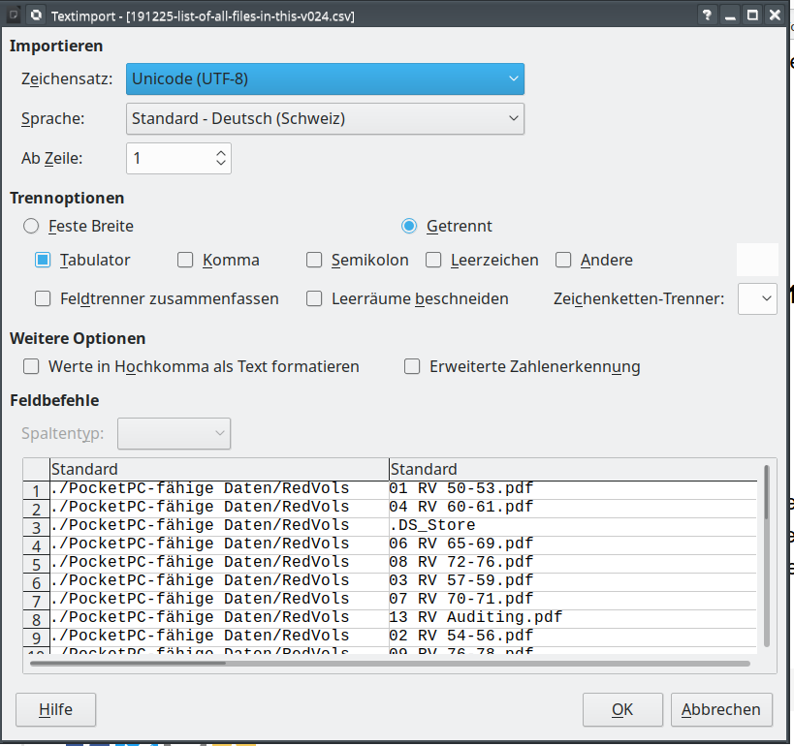
Open the .tsv with LibreOffice Calc
Opening the .tsv with Calc
To take into account that some file names contain a quotation mark, the table must be opened without interpreting the quotation marks:

nohup
cd "/media/res/HDD_V_eBib/eBib/AGs LRH-Daten/eBib/Compare-n-Share/Search-for-Dates/"
nohup perl Search-for-Dates-R19.pl -l -i=200120-list-of-all-files-in-eBib-v032.tsv -o=R19 -f=FoldersToBeIgnored.txt &
nohup: ignoriere Eingabe und hänge Ausgabe an 'nohup.out' an

Duration
1h44 for the entire eBib collection

Commands to apply the app
cd "/media/res/HDD_V_eBib/eBib/AGs LRH-Daten/eBib/Compare-n-Share/Search-for-Dates/"
nohup perl Search-for-Dates-R19.pl -l -i=200814-list-of-all-files-in-eBib-v032.tsv -o=R19 -f=FoldersToBeIgnored.txt &
perl Search-for-Dates-R19.pl -h
############ Search for dates #############
usage: Search-for-Dates.pl [options]
--input|-i=list-of-all-files.csv
--all|-a
--outprefix|-o=outprefix
--delim|-d="\t"
--functdelim|-f=;
--foldersToIgnore|-f
--1date|-1
--xtended|-x
--link|-l
--version|-v
--debug
--help|-h

compare-n-share
Here we have the script which quickly compares the file collections of two persons against each other and delivers as output a list and a copy-batchfile.
Very convenient for collectors. And it is not needed to meet each other or to have both collections on the same system, as each one can prepare his list with list-all-files and then this script will run on it.
You can then use the created Copies-for-Friend.sh script to create a new folder full of the files he needs and zip that and upload it to big-transfer sites.

Usage
perl compare-n-share-v018.pl -h
############ Search for dates #############
usage: compare-n-share-v018.pl [options]
--list-of-friends-files|-f=list-of-friends-files.csv
--list-of-my-files|-m=list-of-my-files.csv
--friendsTarget|--ft=friendsTarget
--MyTarget|--mt=MyTarget
--copy|-c="arguments for linux cp (copy command) in quotes"
--replace|-r
--version|-v
--help|-h
i.e. like this:
perl compare-n-share-v018.pl -f=200811-list-of-all-files-in-Lectures-v032.tsv -m=R19-200120-list-of-all-files-in-eBib-v032.tsv -ft=/media/res/friend -mt=/media/res/mynew

A small bug:
these resulting files are exactly wrong named. Switch Friend and Me and they are correct.
Copies-for-Friend.sh
Copies-for-Me.sh
Files-for-Friend.txt
Files-for-Me.txt

How to Run the Copy-script
just remember to run shell script as
nohup sh sh Copies-for-Me.sh >out.txt &
so that all the failed copy cmds will be in redirected file else failed cmds will be output in console with std error

End of Doc

SHA-256 seems better than MD5. But to avoid collisions does not count here. It is more important, that the calculation of the hash over 1 mio files does not take too long. so performance should be the first criteria. We can neglect the rare case, if we take MD5-hash, that 2 different files get the same hash. At least if the file length is the same too. - So which hash is the quickest to calculate: • https://en.wikipedia.org/wiki/Comparison_of_cryptographic_hash_functions • https://automationrhapsody.com/md5-sha-1-sha-256-sha-512-speed-performance/

